Cursors
What Is a Cursor?
Cursors are a way of taking a set of data and being able to interact with a single record at a time. It doesn’t happen nearly as often as one tends to think, but there are indeed times where you just can’t obtain the results you want to by modifying or even selecting the data in an entire set. The set is generated by something all of the rows have in common (as defined by a SELECT statement), but then you need to deal with those rows on a one-by-one basis.
The result set that you place in a cursor has several distinct features that set it apart from a normal SELECT statement:
❑ You declare the cursor separately from actually executing it.
❑ The cursor and, therefore, its result set are named at declaration; you then refer to it by name.
❑ The result set in a cursor, once opened, stays open until you close it.
❑ Cursors have a special set of commands used to navigate the recordset.

While SQL Server has its own engine to deal with cursors, there are actually a few different object libraries that can also create cursors in SQL Server:
❑ SQL Native Client (used by ADO.NET)
❑ OLE DB (used by ADO)
❑ ODBC (used by RDO, DAO, and in some cases, OLE DB/ADO)
❑ JDBC (used by Java)
❑ DB-Lib (now a distant legacy offering, but still used in some older apps)
These are the libraries that client applications will typically use to access individual records. Each provides its own syntax for navigating the recordset and otherwise managing the cursor. Each, however, shares in the same set of basic concepts, so, once you have got one object model down for cursors, you’re most of the way there for all of them.

Cursor Statements:
We can control the records of a result set with the use of these cursor statements. They are:
- DECLARE
- OPEN
- FETCH
- CLOSE
- DEALLOCATE

DECLARE Statement is used to provide cursor declarations such as name
Of the cursor, the select statement to which result set the cursor should point etc.,

OPEN Statement starts using the cursor. It executes the select statement in the cursor and points the cursor to the first record of the result set.
FETCH statement is used to retrieve the data in the current location and navigate the cursor to the required position.
CLOSE statement stops using the cursor. But the resources used by the cursor are still open.
DEALLOCATE statements removes entire resources that are used by the cursor
@@FETCH_STATUS:Returns the status of the last cursor FETCH statement issued against any cursor currently opened by the connection.

Return value | Description
0 | FETCH statement was successful.
-1 | FETCH statement failed or the row was beyond the result set.
-2 | Row fetching is missed.

Syntax:
DECLARE <cursor name> CURSOR
[LOCAL|GLOBAL]
[FORWARD_ONLY|SCROLL]
[STATIC|KEYSET|DYNAMIC|FAST_FORWARD]
For <select statement>
Example:
Suppose there is a table with some data and indexes. After the index creation, if any modifications are performed on the table, those changes will not reflect directly into the index structure. We have to refresh the index structure on all table using the following statement.
DBCC DBREINDEX (<tablename>)

The above command should be executed for all tables of the database. To perform this task we can make use of the following cursor program:
declare @tblname varchar(255)

declare tblcursor cursor
for select table_name from information_schema.tables
where table_type='base table'

open tblcursor

fetch next from tblcursor into @tblname

while @@fetch_status=0
begin
dbcc dbreindex(@tblname)
fetch next from tblcursor into @tblname
end

close tblcursor
deallocate tblcursor

Scope:
The LOCAL versus GLOBAL option determines the scope of the cursor, that is, what connections and processes can ‘‘see’’ the cursor.

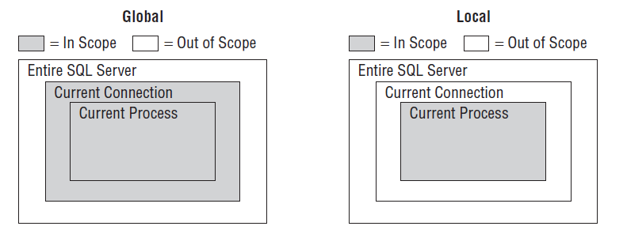

Scrollability
Like most of the concepts we’ll be talking about throughout this chapter, scrollability applies to pretty much any cursor model you might face. The notion is actually fairly simple: Can I navigate in relatively any direction, or am I limited to only moving forward? The default is no. You can only move forward.

FORWARD_ONLY
A forward-only cursor is exactly what it sounds like. Since it is the default method, it probably doesn’t surprise you to hear that it is the only type of cursor that we’ve been using up to this point. When you are using a forward-only cursor, the only navigation option that is valid is FETCH NEXT. You need to be sure that you’re done with each record before you move onto the next because, once it’s gone, there’s no getting back to the previous record unless you close and reopen the cursor.

SCROLLABLE
Again, this is just as it sounds. You can ‘‘scroll’’ the cursor backward and forward as necessary. If you’re using one of the APIs (ODBC, OLE DB, JDBC, and so on), then, depending on what object model you’re dealing with, you can often navigate right to a specific record. Indeed, with ADO, ADO.NET, and LINQ you can even easily resort the data and add additional filters

The cornerstone of scrolling is the FETCH keyword. You can use FETCH to move forward and backward through the cursor, as well as move to specific positions. The main arguments to FETCH are:
❑ NEXT: Move to the next record.
❑ PRIOR: Move to the previous record.
❑ FIRST: Move to the first record.
❑ LAST: Move to the last record.

Static Cursors

A static cursor is one that represents a ‘‘snapshot’’ in time.
When a static cursor is created, the entire recordset is created in what amounts to a temporary table in tempdb. After the time that it’s created, a static cursor changes for no one and nothing. That is, it is set in stone. Some of the different object models will let you update information in a static cursor, some won’t, but the bottom line is always the same: you cannot write updates to the database via a static cursor.

Keyset-Driven Cursors

When we talk about keysets with cursors, we’re not talking your local locksmith. Instead, we’re talking about maintaining a set of data that uniquely identifies the entire row in the database.
Keyset-driven cursors have the following high points:
❑ They require a unique index to exist on the table in question.
❑ Only the keyset is stored in tempdb— not the entire dataset.
❑ They are sensitive to changes to the rows that are already part of the keyset, including the possibility that they have been deleted.
❑ They are, however, not sensitive to new rows that are added after the cursor is created.
❑ Keyset cursors can be used as the basis for a cursor that is going to perform updates to the data.
Given that it has a name of ‘‘keyset’’ and that I’ve already said that the keyset uniquely identifies each row, it probably doesn’t shock you in any way that you must have a unique index of some kind (usually a primary key, but it could also be any index that is explicitly defined as unique) to create the keyset from.

Dynamic Cursors

Reflects all kind of changes

If you want inserted records to be added to the cursor — no problem. If you want updated rows to appear properly updated in the cursor — no problem. If you want deleted records to be removed from the cursor set — no problem (although you can’t really tell that something’s been deleted since you won’t see the missing record that you saw with a keyset cursor type). If, however, you want to have concurrency — uh oh, big problem. (You’re holding things open longer, so collisions with other users are more likely.) If you want this to be low overhead — uh oh, big problem again. (You are effectively requerying with
every FETCH.) Yes, dynamic cursors can be the bane of your performance existence, but, hey, that’s life isn’t it?

